Background
Many urban cities are introducing Rental Bikes to improve the mobility and improve the living standard and comfort of the citizens. But, making sure that the bikes are available at a notice and there is no shortage of this is very important.
As a result, we will be analysing the given dataset with a variety of classifiers which might help us foresee the factors the contribute to the “High Use” of the bikes.
Data Source
This data contains the count of bicycles rented per hour in the city of Seoul, Korea. It also includes the corresponding weather data and the holiday index.

Preliminary Data Preparation
1) Rename all variables with your initials appended (just as was done in previous assignments). Remember that any variables you subsequently create need to have your initials appended.
I have renamed all the variables by appending them with my initials NM. Moreover, I have also renamed the variables to their respective names according to the appendix for better readability.
(Note: I have factored the categorical columns before splitting the data and have not standardized the data. I will explain this in depth in future points)

2) Delete the observation with Temp > 155
I have deleted the observation in the variable Temperature_(C)_NM as mentioned in the question. As we can see from the boxplot there are no outliers anymore.
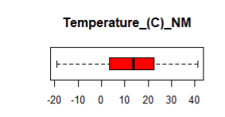

3) Create a new variable in the dataset called HB_[Initials] which will have a value of 1 if RBC ≥ 1700 and 0 otherwise. Delete the RBC variable afterwards.
I have made the new variable HB_NM which stores the data from the RBC dimension. If the observation value is greater than and equal to 1700, we are storing it as 1, 0 otherwise.
Head of the HB_NM column.
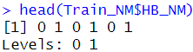

Outliers and Explanation
I have checked the dataset for outliers for both the full dataset and the train dataset. Since, I won’t be removing any outliers and I will be keeping this section here. And since we don’t know the proper timing of when this data waws gathered we can’t deal with outliers in a proper manner.
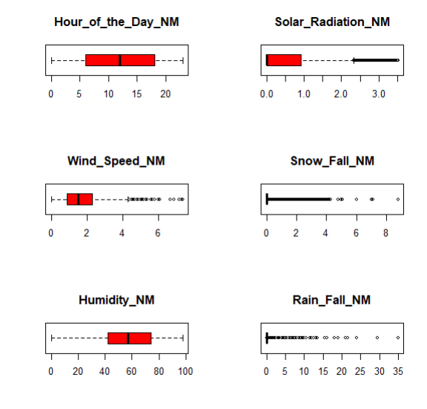
Here we can see that there are a lot of outliers when it comes to variables such as Solar Radiation, Snow Fall, Wind Speed and Rain Fall. We can remove them but upon further research I understood that the average values for all of these variables for the city of Seoul fall well under the values which are being identified as outliers by the IQR equation and the Boxplots.
I will be attaching some images from the reference link I found which states the average values for all the variables in Seoul. I will be citing the link in the references section.
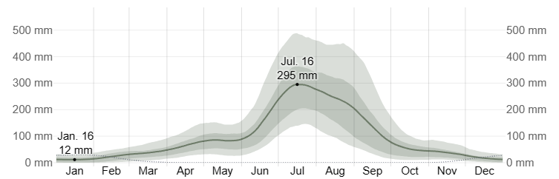
Average Rainfall in Seoul
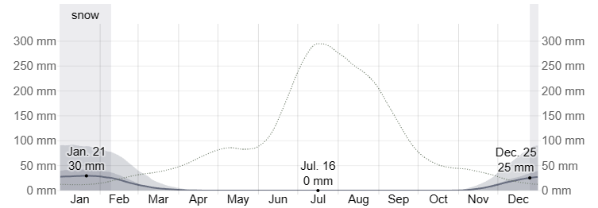
Average Snowfall in Seoul
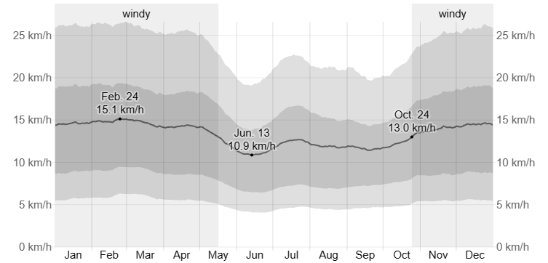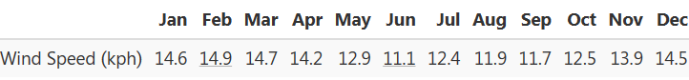
Average Wind Speed in Seoul.
Here as we can see all the outliers presented in the boxplots and even by the IQR calculations in R-studio all fall in the well-defined average values in Seoul. As a result, I have decided not to remove any of the outliers.
Furthermore, the full list of outliers for each of these variables goes into thousands, I won’t be attaching the R-Studio screenshot in here. You can check those in the R-code itself for your reference.

Splitting the Data into Test and Train
I have used the “caret” function here to split the data so that the HB_NM column has equal representation across both the Test and Train datasets. I have done this because we will be testing and predicting our models keeping the HB_NM dimension as the dependant variable.
I have split them as 75% training data and 25% test data.
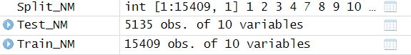

Summary of Train Data
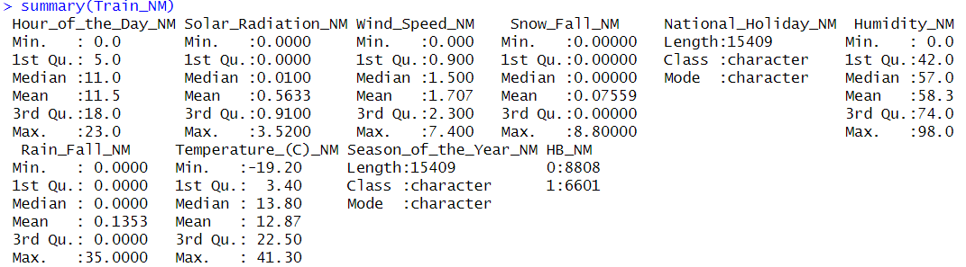

(The reason for not standardizing the data before-hand was because the range and the format of the data is not wildly fluctuating like previous instances. Moreover, I conducted the prediction in three different manners.
- Where I did standardization and factoring only for the train data and kept the test data untouched.
- Where I did standardization and factoring before splitting the data.
- Where I did not do standardization but did the factoring before splitting the data.
And the results for the latter two were identical. Therefore, with the lack of information why this was the case but based on my understanding I have decided to keep the data unstandardized.)

Exploratory Analysis
- Correlations: Create correlations (as demonstrated) and comment on what you see. Are there co-linear variables?
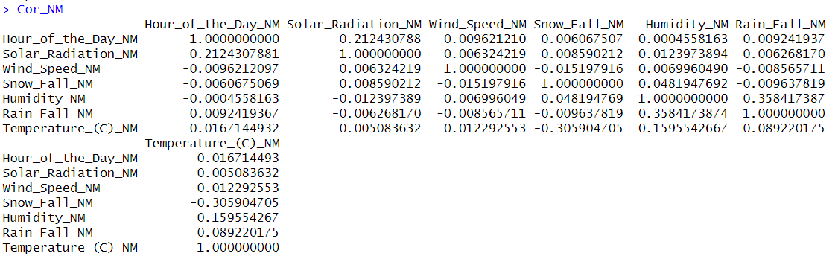
Spearman Method
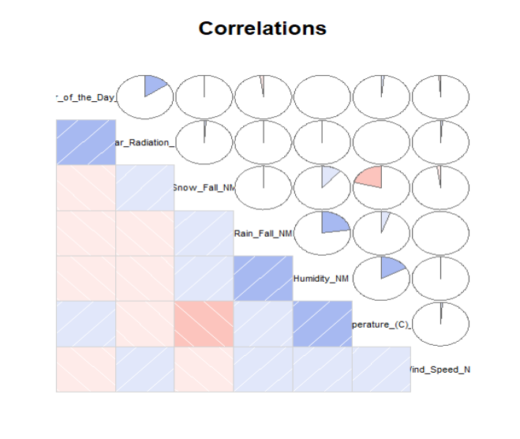
Pictorial Representation

As we can infer from the correlations, there are not any particularly high correlations between the variables. Which means that they all are significantly different from one another. Hence, not removing any variable due to correlations.
Some interesting details to comment on:
- Snowfall and temperature have a negative correlation of -0.3 which makes sense as lower temperatures result in snowfall but when it is snowing the temperatures are not drastically negative.
- Humidity and Rainfall have a positive weak correlation of 0.36. This also makes sense as rain does occur in humid conditions.
- Hour of the Day and Solar Radiation have a weak correlation of 0.21. This is self-explanatory. Solar radiation increases when we reach mid-day or when the hour of the day increases.
Missing Values Filter
There are no missing values in our dataset.
Low Variance Filter
The variables all show variance and none of them are particularly low in their variance values. As a result, we will be keeping the variables.
Histograms
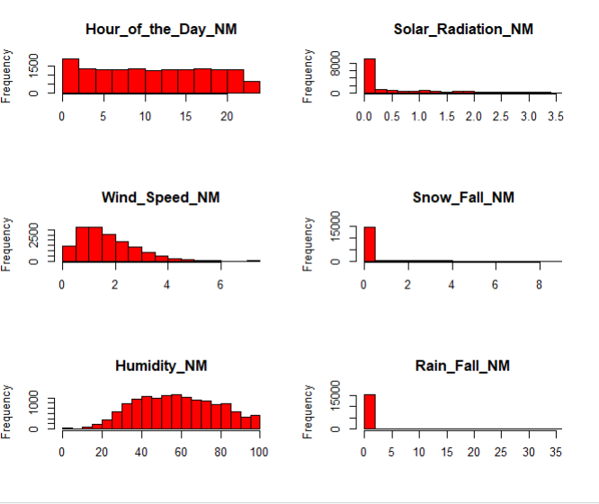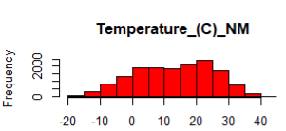
These are the Histograms for the variables in the Train dataset. Here, we can see the spread of the data points in the variable. Something to note is that the major values for the variables Snowfall, Rainfall and Solar Radiation are all a singular value. This makes sense as Seoul is a seasonal countries and rainfall and snowfall only happens in their respective seasons. As a result, during the other time periods the value comes out as 0.

Model Development
As demonstrated in class, create two logistic regression models
1) A full model using all of the variables, interpret and comment on the main measures we discussed in class: (1) Fisher iterations (2) AIC (3) Residual Deviance (4) z-values (5) Parameter Co-Efficient
Here I have made the Full model and the subsequent step model by using the HB_NM column as the dependant variable.
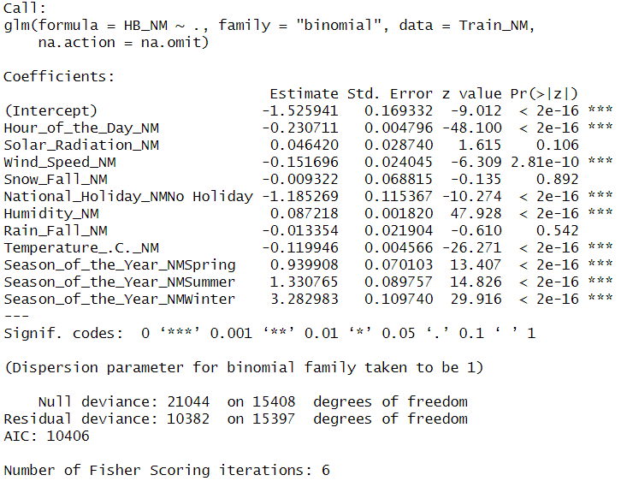
This is the Full Model. Let’s take a look at the measures used to interpret if a model is good fit or a bad fit.
- Fisher Iterations: This is the method for solving the maximum likelihood and it converges. Number of iterations performed during the fitting process. Here 6 iterations were performed.
- AIC: Akaike Information Criteria (AIC) is very similar to R-Squared but can’t be interpreted on its own. Here we check whether the value is lower or not. AIC measures the quality of the model by balancing the goodness of the fit and the complexity of the model. Here the AIC score is 10406.
- Residual Deviance: This measures how well the data actually fits the model and the smaller the better.
- Z-value: Also known as Wald z-statistic. This represents the significance of each independent variable. Larger the value better the predictor. They also have asterisk (***) to show the significance level.
- Parameter Coefficients: The parameter coefficients relate to the log-odds of the logits. They also indicate the strength and the direction of the relationship between the predictors and the response. Here we have to consider whether they are positive or negative and their significance level.
2) An additional model using backwards, stepwise or manual selection. Once again, interpret and comment on the same 5 measures.
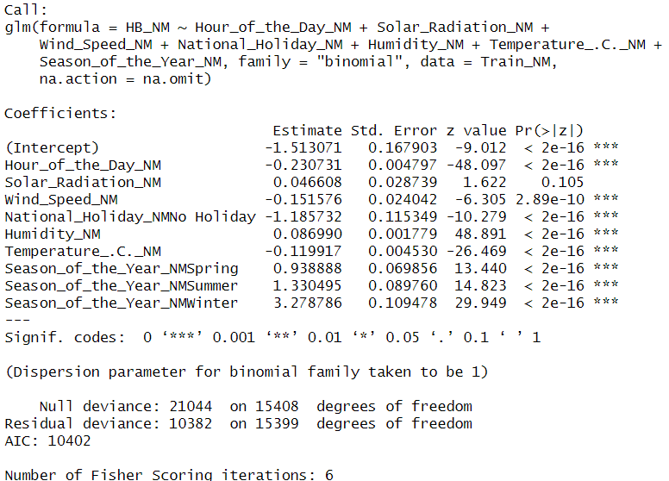
This is the stepwise selection model. The model goes through multiple iteration by either adding or removing predictors based on statistics. Let’s take a look at the measures.
- Fisher Score: Here the fisher score is 6 which is the same as the Full model.
- AIC: As mentioned earlier, the lower the AIC score the better the model. Here the AIC score is 10402 which is lower than the Full Model (albeit by only one value).
- Residual Deviance: Once again as mentioned earlier, the residual deviance should be smaller. But here it is the same for both the models => 10382.
- Z-values: The z-values for both the models and their predictors are highly similar and comparable with each other.
- Parameter Coefficients: These coefficients measure the strength and the magnitude of the predictors. These are similar to the Full model as well.
3) As demonstrated in class, analyse the output for any significantly influential datapoints. Are there any?
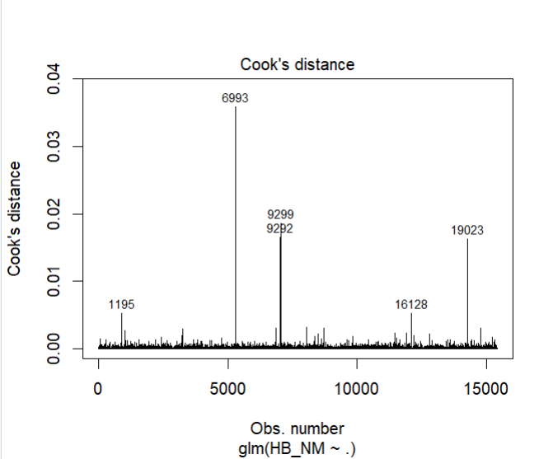
Cook’s distance for Full Model
As seen by the Cook’s distance plot there are some influential cases or data points such as 6993, 9299, 9292, 16128, 19023. The residual plot is a constant stream of dots across the middle line meaning that the residuals are all constantly distributed.

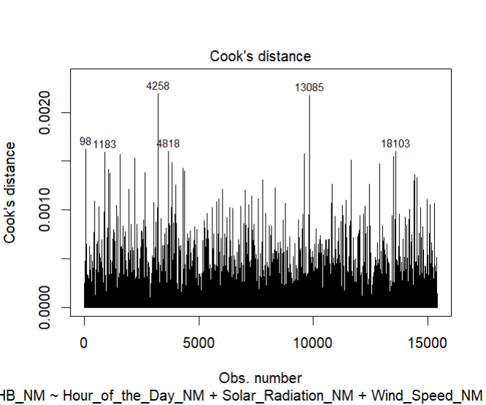
Cook’s distance for Step Model.
Here there are a lot of influential cases when compared to the Full Model. Similarly, here as well the residuals are constant.

4) Based on your preceding analysis, recommend which model should be selected and explain why
Based on the calculations conducted earlier and the Cook’s plots we can say that the stepwise selection model is the better of the two models. Although, most of the values of the measures for both the plots are pretty similar (indicating that both the models are pretty good fits for the data), I would like to recommend the Stepwise selection model as the AIC value of the model is lower than the Full model.

Part-B
In this section, all classifiers should be built using HB_[Intials] as the dependant variable and the remaining variables as the independent variables
1) Logistics Regression – stepwisef
1) As above, use the step option in the glm function to fit the model (using stepwise selection)
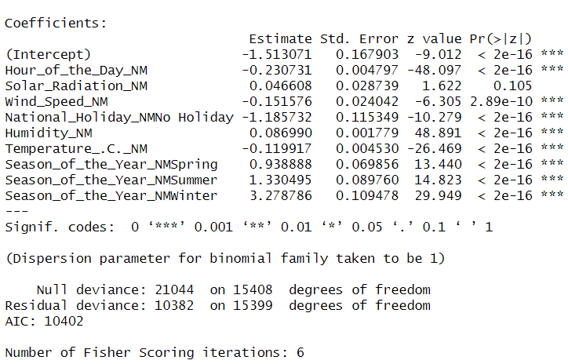
Stepwise Model
This is the Stepwise Selection model as seen earlier. The model iteratively selects and removes predictors based on statistical significance.

2) Summarize the results in Confusion Matrices for both train and test sets.
Confusion Matrix for Train Data:
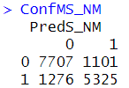
This is the confusion matrix for the train dataset for the Stepwise Model. Here we can see the False Positive and the False Negative values are quite well balanced. The accuracy rate for the train dataset is 84% which is pretty good. This states that the model can predict 84 values correctly out of 100. True Negatives are 7707 and True Positives are 5325.
Confusion Matrix for Test Data:
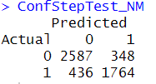
This is the Confusion Matrix for stepwise model with the test dataset. Here the accuracy for the test set is also 84%. The distribution of the false positive and false negative is also quite proportional.

3) Calculate the time (in seconds) it took to fit the model and include this in your summary.
The time difference is 1.55 seconds.

2) Naïve-Bayes Classification
1) Use all the variables in the dataset to fit a Naïve-Bayesian classification model.
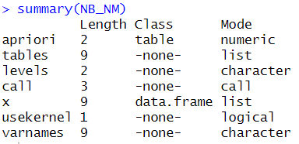
This is the summary for the Naïve Bayes Model. Here we can see the length, Mode and the Class of the datasets along with the levels, tables etc variables.
2) Summarize the results in Confusion Matrices for both train and test sets.
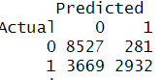
Here’s the confusion matrix for the train dataset. We can see that the False negatives and false positive are very out of proportion. The accuracy for this model is 74%.

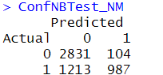
This is the confusion matrix for the Naïve Bayes with the test dataset. The case with the false positive and the false negatives are also similarly way out of proportion with the test dataset. Here the accuracy is 74%.

3) Calculate the time (in seconds) it took to fit the model and include this in your summary.
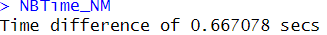
My Naïve Bayes takes around 13 seconds. I believe this might be the case of my potato laptop and that I have a lot of programs open. Don’t put too much attention to this. I believe it should take around 1 sec of time to actually conduct.

3) Recursive Partitioning Analysis
1) Use all the variables in the dataset to fit a recursive partitioning classification model.
Recursive Partitioning model makes decision trees. The process recursively adds and removes or splits the dataset based on the input features. With the aim to minimize the error in the splits and the dataset.
2) Summarize the results in Confusion Matrices for both train and test sets.
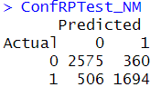
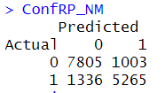
Here we can see the Confusion Matrix of the Recursive partitioning model on the train dataset. Here the accuracy comes out to be 84%

This is the confusion matrix for the test data set. The accuracy comes out to be 83%
3) Calculate the time (in seconds) it took to fit the model and include this in your summary
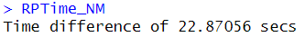
This is the time difference for the recursive partitioning model.

- Compare All Classifier
For all questions below please provide evidence. 1. Which classifier is most accurate? 2. Which classifier seems most consistent (think train and test)? 3. Which classifier is most suitable when processing speed is most important? 4. Which classifier minimizes false positives? 5. In your opinion, classifier is best overall?

Based on the accuracies from all the models the model with the best accuracy comes out to be the Stepwise model with 84% accuracy.
When we think about consistency the model with the most consistent results can be checked with the help of the confusion matrix and the accuracy rates between both the train and test data. Both stepwise and the Naïve Bayes give more consistent results.
When taking processing speed into the account the Naïve Bayes is the fastest with only a time of 0.6 second. The longest time taken is by recursive partitioning with 22 seconds.
When taking false positives into account the recursive partitioning model minimizes the false positives the most.
If accuracy is the concern, then recursive partitioning is the best model to recommend as it is consistent and is also the most accurate. It also minimises the false positives. When time is the consideration Naïve Bayes can be considered as the better model as it has the slowest amount of time taken for model generation. As a result, we can recommend either the recursive partitioning or the Naïve Bayes model. But taking accuracy into account I would like to recommend Recursive Partitioning Model.

References:

- Seoul Climate, weather by month, Average temperature (South Korea) - Weather Spark. (n.d.). Weather Spark. https://weatherspark.com/y/142033/Average-Weather-in-Seoul-South-Korea-Year-Round

